SUNDAY  December 2019 | MONDAY | TUESDAY | WEDNESDAY | THURSDAY | FRIDAY | SATURDAY
1 | 2  Aged Care Meeting 3:30pm | 3 | 4 | 5  Jim M Bday | 6  Rummikub  9:00am | 7  Wendy H Bday
8 | 9 | 10 | 11 | 12  Jan L Bday | 13  CHRISTMAS  HOY  Last day of school | 14  School Holidays
15 | 16  Diversional Therapy Group Session 9:00am | 17 | 18  Maurice H & Ted B Bday | 19 | 20  BCACAI OFFICE CLOSES. REOPENS 06/01/2020 | 21
22 | 23 | 24  Christmas Eve | 25  Christmas Day | 26  Boxing Day | 27 | 28
29  Terry C Bday | 30 | 31  New Years Eve
SUNDAY  November 2019 | MONDAY | TUESDAY | WEDNESDAY | THURSDAY | FRIDAY | SATURDAY
 |  |  |  |  | 1  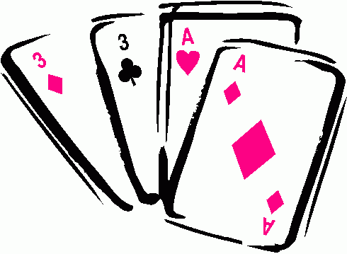  HOY | 2
3 | 4 | 5  Melbourne Cup Luncheon at Bowls Club | 6 | 7 | 8  Rummikub | 9
10 | 11  Remembrance Day | 12  Coffee on the Footpath 10am | 13 | 14 | 15  HOY | 16
17 | 18 | 19 BMPHS Morning 10am  Marj H Birthday | 20 | 21 | 22  Rummikub | 23
24 | 25  Diversional Therapy Group Session 9:00am | 26 | 27  Moura School of Ballet Concert Trip | 28 | 29  HOY | 30

